FAKE NEWS DELECTION SYSTEM

A CAPSTONE PROJECT REPORT

Submitted in partial Fulfillment of the requirements for the Course of

CSA1711 ARTIFICAL INTELLIGENCE
to the award of the degree of

BACHELOR OF ENGINEERING / TECHNOLOGY
In

COMPUTER SCIENCE ENGINEERING

By

ADDAGADA MEGHANADH (192572132)

A.THARUN KUMAR REDDY(192572068)
Under the Supervision of

Dr. K.KRISHNAKUMAR

SIMATS ENGINEERING

SAVEETHA INSTITUTE OF MEDICAL AND TECHNICAL SCIENCES
Chennai - 602105

SEPTEMBER-2026




SIMATS ENGINEERING

SAVEETHA INSTITUTE OF MEDICAL AND TECHNICAL SCIENCES CHENNAI-602105

DECLARATION

We, Saveetha Institute of Medical and Technical Science, Saveetha University, Chennai, hereby declare that the Capstone Project Work entitled FAKE NEWS DELECTION SYSTEM IS the result of our own bonafide efforts. To the best of our knowledge, the work presented herein is original, accurate, and has been carried out in accordance with principles of engineering ethics.

Place: SIMATS Engineering, Chennai. Date:

STUDENT SIGNATURE WITH NAMES

A.THARUN KUMAR REDDY(192572068)

ADDAGADA MEGHANADH (192572132)




SIMATS ENGINEERING
Saveetha Institute of Medical and Technical Sciences Chennai-602105

BONAFIDE CERTIFICATE

This is to certify that the Capstone project entitled FAKE NEWS DELECTION SYSTEM submitted by @ under the supervision of and is submitted in the Partial fulfillment of the requirements for the current semester of the program at SIMATS Engineering, Saveetha Institute of Medical and Technical Science, Chennai – 602105.

Submitted for the Project work Viva-Voce held on

INTERNAL EXAMINER EXTERNAL EXAMINER

ACKNOWLEDGEMENT

We would like to express our heartfelt gratitude to all those who supported and guided us throughout the successful completion of our Capstone Project. We are deeply thankful to our respected Founder and Chancellor, Dr. N.M. Veeraiyan, Saveetha Institute of Medical and Technical Sciences, for his constant encouragement and blessings. We also express our sincere thanks to our Pro-Chancellor, Dr. Deepak Nallaswamy Veeraiyan, and our Vice- Chancellor, Dr. S. Suresh Kumar, for their visionary leadership and moral support during the course of this project.
We are truly grateful to our Director, Dr. Ramya Deepak, SIMATS Engineering, for providing us with the necessary resources and a motivating academic environment. Our special thanks to our Principal, Dr. B. Ramesh for granting us access to the institute’s facilities and encouraging us throughout the process. We sincerely thank our Dr. F. Mary Anjalin for his continuous support, valuable guidance, and constant motivation. We are especially indebted to our guide, Dr. K.KRISHNAKUMARfor her creative suggestions, consistent feedback, and unwavering support during each stage of the project. WE also express our gratitude to the Project Coordinators, Review Panel Members (Internal and External), and the entire faculty team for their constructive feedback and valuable inputs that helped improve the quality of our work. Finally, we thank all faculty members, lab technicians, our parents, and friends for their continuous encouragement and support.

STUDENT SIGNATURE WITH NAMES

A.THARUN KUMAR REDDY(192572068)

ADDAGADA MEGHANADH (192572132)

INDIVIDUAL CONTRIBUTION STATEMENT

Mandatory for the two-member team project.

Student  Name /  Register No. | Specific Responsibilitie s | Design &  Development  Contribution | Testing &  Analysis  Contribution | Report  Contribution | Approx.  Contribution  (%)
ADDAGADA  MEGHANAD  H / 192572132 | Dataset preparation, preprocessing, TF-IDF and model development | Data preprocessing, feature extraction, classifier  implementation | Model testing, evaluation metrics and result interpretation | Chapters 1, 3 and results sections | 50%
A. THARUN  KUMAR  REDDY /  192572068 | System workflow, documentation, visualization and validation | System  architecture, workflow and implementation support | Graphs, confusionmatrix interpretation and verification | Chapters 2, 4 and 5 | 50%
Total |  |  |  |  | 100%

INDEX

S. NO. | TABLE OF CONTENTS LIST OF FIGURES | PAGE NO.
1 | ABSTRACT | 6
2 | INTRODUCTION | 7-8
3 | PROBLEM IDENTIFICATION AND ANALYSIS | 9-11
4 | SOLUTION DESIGN AND IMPLEMENTATION | 12-13
5 | RESULTS AND RECOMMENDATIONS | 14-15
6 | REFLECTION ON LEARNING AND PERSONAL  DEVELOPMENT | 16-17
7 | CONCLUSION | 18
8 | REFERENCES | 19
9 | APPENDICES | 20-23

Figure No. | Figure Name | Page No.
Figure 1 | Misinformation and disinformation without knowing its real or fake | 11
Figure 2 | End-to-End Fake News Detection Workflow | 12
Figure 3 | AI Development Workflow Stages – Bar Graph | 20
Figure 4 | Conceptual Pipeline Progression – Line Graph | 21
Figure 5 | Technology Categories Used – Pie Chart | 22
Figure 6 | Illustrative Growth of Text Feature Space – Scatter Graph | 23

LIST OF FIGURES

LIST OF TABLES

Table No. | Table Name | Page No.
Table 1.1 | Project Objectives | 8
Table 1.2 | Project Scope | 9
Table 2.1 | Stakeholders Affected | 10
Table 2.2 | Supporting AI / NLP Approaches | 11
Table 3.1 | Tools and Technologies Used | 14
Table 3.2 | Development and Design Process | 15
Table 3.3 | Alternative Machine Learning Solutions | 16
Table 3.4 | Engineering Standards and Quality Practices | 17
Table 3.5 | Sustainability, Ethics, Safety, Security and Risk Evaluation | 18
Table 4.1 | Evaluation Metrics and Acceptance Criteria | 20
Table 4.2 | Future Improvement Priorities | 24
Table 4.3 | Three-Member Team Roles and Contributions | 25
Table 4.4 | Project Timeline / Milestones | 26

ABSTRACT

The rapid growth of the internet, online news platforms, and social media has significantly changed the way information is created, distributed, and consumed. Millions of news articles, posts, and messages are shared every day, enabling people to access information quickly and easily. However, this rapid flow of information has also created a major challenge: the widespread dissemination of fake news. Fake news refers to misleading, fabricated, or intentionally manipulated information presented as genuine news. Such information can influence public opinion, create unnecessary fear and confusion, damage the reputation of individuals and organizations, and negatively affect important social, political, economic, and public issues. Since manually verifying every news article is difficult, time-consuming, and requires expert knowledge, there is a growing need for automated systems capable of identifying potentially fake news.
The Fake News Detection System proposed in this project uses Natural Language Processing (NLP) and Machine Learning techniques to classify news content as real or fake based on textual patterns and information learned from a labelled dataset. The system begins by collecting and loading a dataset containing news articles along with their corresponding labels. The textual data is then preprocessed to remove unnecessary information, handle missing values, and prepare the content for machine learning. Important textual features are extracted using the Term Frequency–Inverse Document Frequency (TF-IDF) technique, which converts textual documents into numerical representations while emphasizing important words and reducing the influence of commonly occurring terms.
After feature extraction, the dataset is divided into training and testing data. A Multinomial Naïve Bayes algorithm is used as the primary classification method because it is efficient and well suited for text-based classification problems. The trained model learns the relationship between textual features and news labels and then predicts the category of previously unseen news content. The performance of the system can be evaluated using measures such as accuracy, precision, recall, F1-score, and a confusion matrix.

INTRODUCTION

1.1 Background Information

Fake news refers to information that is fabricated, manipulated, or presented in a misleading manner while appearing to be genuine news. The rapid spread of fake news can create confusion among the public, influence opinions, damage reputations, and affect important social and political decisions. Social media platforms allow users to share information quickly, making it difficult to verify the authenticity of every article or post manually.

Traditional fact-checking requires human experts to examine information, verify sources, and compare claims with reliable evidence. However, due to the enormous amount of online content generated every day, manual verification alone is time-consuming and difficult to scale. Therefore, automated fake news detection systems have become increasingly important .

Natural Language Processing (NLP) and Machine Learning provide effective techniques for analysing textual information automatically. NLP helps computers process and understand human language, while machine learning algorithms can learn patterns from previously labelled examples. In this project, textual news data is processed and converted into numerical features using the Term Frequency–Inverse Document Frequency (TF-IDF) technique. These features are then used to train a machine learning classifier, such as Multinomial Naïve Bayes, to predict whether a news article belongs to the fake or real category.

The Fake News Detection System provides a practical application of artificial intelligence for addressing misinformation. It demonstrates how data preprocessing, feature extraction, machine learning, and model evaluation can be combined to create an automated text classification system.

1.2 Project Objectives

The main objectives of the Fake News Detection System are:

To develop an automated system for detecting fake news from textual content.

To collect and process labelled news data for machine learning.

To clean and preprocess textual news articles using Natural Language Processing techniques.

To convert textual data into numerical features using the TF-IDF vectorization technique.

To train a machine learning model for classifying news as Fake or Real.

To use the Multinomial Naïve Bayes algorithm for text classification.

To evaluate the performance of the developed model using appropriate evaluation metrics.

To calculate accuracy, precision, recall, and F1-score.

To analyse classification results using a confusion matrix.

To provide predictions for newly entered news content.

The project demonstrates the practical use of Natural Language Processing and Machine Learning for analysing large volumes of textual information. Instead of manually examining every news article, the trained system can process text automatically and generate a predicted category.

The project is also significant from an educational perspective. It provides practical experience in Python programming, data preprocessing, feature extraction, supervised learning, probabilistic classification, and performance evaluation. Students and researchers can understand how a complete machine learning workflow is developed from dataset collection to final prediction.

The proposed system can also serve as a foundation for future applications in social media monitoring, digital journalism, content moderation, cybersecurity, and information verification. Although automated detection should not replace professional fact-checking, it can act as a useful supporting tool for identifying suspicious content.

1.4 Scope of the Project

The scope of the Fake News Detection System focuses primarily on the classification of textual news articles.

The system uses a labelled dataset containing examples of real and fake news to train a machine learning model.

The major activities included within the scope of the project are:

Collection of a labelled fake news dataset.

Loading the dataset using Python.

Handling missing or incomplete data.

Preprocessing and cleaning textual news content.

Feature extraction using TF-IDF.

Splitting the dataset into training and testing data.

Training the Multinomial Naïve Bayes classification model.

Evaluating model performance.

Generating predictions for new news text.

The project mainly focuses on text-based classification. It does not independently verify every factual statement

external evidence. The prediction is based on patterns learned from the labelled training data.

The system can be extended in the future by including multiple languages, source credibility analysis, real-time social media data, image and video analysis, deep learning models, and integration with professional fact-checking platforms.

1.5 Methodology Overview

The fourth step is data splitting. The processed dataset is divided into training data and testing data. The training data is used to teach the machine learning model, while the testing data is used to evaluate its performance. The fifth step is model training. The Multinomial Naïve Bayes algorithm is trained using the TF-IDF features and corresponding labels. The algorithm learns statistical relationships between words and news categories. The sixth step is model evaluation. The predictions generated for the testing dataset are compared with the actual labels. Performance is evaluated using accuracy, precision, recall, F1-score, and a confusion matrix.



Fig-1: Misinformation and disinformation without knowing its real or fake

Objective ID | Measurable Objective | Evidence
O1 | To design an automated system for detecting fake news from textual content. | Implementation / test evidence
O2 | To collect and process labelled | Implementation / test evidence
 | news data for machine learning.
O3 | To clean and preprocess textual news articles using NLP techniques. | Implementation / test evidence
O4 | To convert textual data into numerical features using TF-IDF. | Implementation / test evidence
O5 | To train a Multinomial Naïve Bayes model for Fake/Real classification. | Implementation / test evidence
O6 | To evaluate the model using accuracy, precision, recall, F1score, and a confusion matrix. | Implementation / test evidence
O7 | To generate predictions for newly entered news content. | Implementation / test evidence

PROBLEM AND IDENTIFICATION ANALYSIS
2.1 Description of the Problem
The rapid growth of the internet and social media has made it easier for people to access and share information. News can now reach thousands or millions of users within a short period. However, this rapid exchange of information has also resulted in the widespread distribution of fake news. Fake news refers to false, misleading, manipulated, or fabricated information that is presented as genuine news. Such content may be intentionally created to influence public opinion, attract website traffic, create confusion, damage reputations, or mislead people about important events. One of the major problems is that users often find it difficult to distinguish between genuine and fake news. Fake articles may use professional-looking websites, attractive headlines, emotional language, and misleading information to appear trustworthy. Social media platforms also allow users to share content rapidly without verifying its accuracy. Manual fact-checking is an important method for identifying misinformation, but it requires time, expert knowledge, and reliable sources. Due to the huge amount of online content generated every day, it is difficult for human fact-checkers to verify every article or social media post. Therefore, there is a need for an automated Fake News Detection System that can analyse textual content and identify patterns associated with fake or real news. The proposed system uses Natural Language Processing (NLP) and Machine Learning techniques to process news articles and classify them based on patterns learned from labelled datasets. The main problem addressed by this project is the development of an efficient automated system that can perform the initial classification of news content and help identify potentially misleading information.
2.2 Evidence of the Problem
The growth of digital media has significantly increased the volume of information available online. News websites, blogs, messaging applications, and social media platforms allow information to be published and shared instantly. While this provides fast access to information, it also creates opportunities for misleading content to spread quickly. Fake news can be difficult to identify because false information may be written in a style similar to genuine news articles. It may contain realistic headlines, names, locations, and statements that make it appear authentic. Users may share such information based only on headlines without checking the original source.
The major evidence supporting this problem includes:
- High volume of online information:
Large quantities of articles and social media posts are created continuously, making manual verification difficult.
- Rapid information sharing:
Digital platforms allow users to share information immediately with a large audience.
- Difficulty of manual verification:
Human fact-checking requires time and expert analysis and cannot easily scale to every online article.
- Misleading writing patterns:
Fake news may use sensational headlines and emotional language to attract attention and encourage sharing.
- Availability of labelled datasets:
Research datasets containing examples of real and fake news demonstrate that misinformation detection is an important problem that can be studied using machine learning techniques.
These factors demonstrate the importance of developing automated systems that can assist in analysing and classifying online news content.
2.3 Stakeholders Affected
The spread of fake news affects many individuals and organizations. The major stakeholders associated with this problem are described below.
1. General Public
The general public is one of the most affected groups. People may make decisions based on false or misleading information. Fake news can create confusion, fear, and misunderstanding.
2. Journalists and Media Organizations
Journalists and media organizations may face challenges when false information is presented as legitimate news. Fake content can reduce public trust in reliable news sources and increase the need for fact-checking.
3. Social Media Platforms
Social media platforms are responsible for managing large amounts of user-generated content. Automated fake news detection systems can assist these platforms by identifying potentially suspicious content for further review.
4. Fact-Checking Organizations
Fact-checking organizations manually verify claims and information. Since large volumes of content are produced every day, automated machine learning systems can help prioritize potentially misleading articles for investigation.
5. Government and Public Institutions
False information about public events, policies, and important announcements can create confusion among citizens. Therefore, public institutions are also affected by the spread of misinformation.
6. Businesses and Organizations
Fake information can damage the reputation of companies and organizations. False reports may influence customer opinions and create unnecessary concerns.
7. Students and Researchers
Students and researchers studying NLP, artificial intelligence, and machine learning benefit from fake news datasets and detection systems. The problem provides an important real-world application of text classification techniques.
Existing Approach | Advantages | Limitations | Relevance to Proposed  Work
Multinomial Naïve  Bayes | Efficient and well suited to text classification | Limited contextual understanding | Selected as primary classifier
Logistic Regression | Strong classical textclassification baseline | Requires tuning | Future comparison
Support Vector Machine | Effective with highdimensional text features | More tuning/compute may be required | Future comparison
Decision Tree / Random  Forest | Flexible classification approach | Less direct for sparse text representation | Future comparison
Deep Learning /  Transformers | Strong contextual understanding | Higher data and computational | Future work
 |  | requirements

2.4 Supporting Data/Research
Research in the fields of Natural Language Processing, Machine Learning, and Data Mining has demonstrated that textual information can be analysed automatically to identify patterns associated with different categories of content. Fake news detection datasets generally contain news articles with corresponding labels such as Fake and Real. These datasets allow machine learning algorithms to learn relationships between textual features and news categories. One of the commonly used techniques for text classification is Term Frequency–Inverse Document Frequency (TF-IDF). TF-IDF converts textual documents into numerical feature vectors. It gives greater importance to words that are significant within a particular document while reducing the importance of words that occur frequently across many documents. The Naïve Bayes algorithm is widely used for text classification because it is efficient and works effectively with high-dimensional textual data. In this project, the Multinomial Naïve Bayes algorithm can learn from TF-IDF features and predict the probability of a news article belonging to a particular category.
Previous research on fake news detection has also explored algorithms such as:
- Naïve Bayes
- Logistic Regression
- Support Vector Machine (SVM)
- Decision Tree
- Random Forest
- Deep Learning Models
These studies demonstrate that machine learning can be used as a useful tool for analysing large volumes of textual information. However, the performance of a fake news detection system depends on several factors, including the quality and size of the dataset, preprocessing techniques, feature extraction methods, class balance, and the selected machine learning algorithm. Therefore, the proposed Fake News Detection System uses a structured methodology involving data collection, text preprocessing, TF-IDF feature extraction, train-test splitting, Multinomial Naïve Bayes classification, and performance evaluation. The system provides an automated approach for the initial identification of potentially fake news while demonstrating the practical application of NLP and machine learning to a real-world misinformation problem.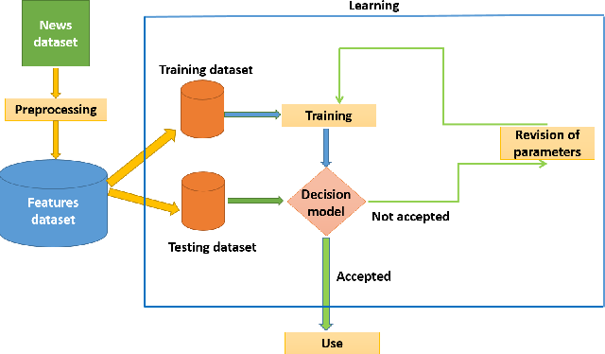

Fig-2: End-to-End Fake News Detection Workflow

2.6 Supporting AI / NLP Approaches
Approach | Purpose in Fake News Detection | Project Position
Naïve Bayes | Probabilistic text classification | Primary implementation
Logistic Regression | Classical supervised baseline | Future comparison
SVM | High-dimensional text classification | Future comparison
Decision Tree / Random Forest | Alternative supervised classification | Future comparison
Deep Learning / Transformers | Contextual and semantic modelling | Future work

Solution Design and Implementation

3.1 Requirements

3.1.1 Stakeholder / User Requirements
Stakeholder / User | Requirement
General public | Receive an understandable initial Fake/Real classification.
Journalists / media organizations | Screen large volumes of textual content for further review.
Fact-checking organizations | Prioritize potentially suspicious articles for investigation.
Social media / digital platforms | Use automated screening as an assistive component, subject to human review.
Students / researchers | Use the workflow as an educational NLP/ML application.

3.1.2 Functional & Non-Functional Requirements
Requirement Type | Requirement | Measurable Target
Functional | Load labelled news dataset | Dataset successfully read and validated
Functional | Preprocess text | Usable cleaned text representation
Functional | Extract TF-IDF features | Sparse numerical feature matrix generated
Functional | Train classifier | Multinomial Naïve Bayes model fitted
Functional | Predict class | Fake/Real output generated for test/new text
Functional | Evaluate model | Accuracy, precision, recall, F1 and confusion matrix produced
Non-Functional | Reproducibility | Fixed random state / documented workflow
Non-Functional | Maintainability | Logical modular stages and clear documentation
Non-Functional | Safety / ethics | Output presented as prediction, not absolute truth

3.2 Constraints & Applicable Standards
Standard / Practice | Requirement | How Applied in This Project
Structured software development practice | Separate development stages and clear documentation | Data, preprocessing, modelling, testing and reporting are treated as distinct stages.
Data quality practice | Check missing/inconsistent records | Dataset is inspected and cleaned before model training.
Machine-learning evaluation practice | Use multiple performance metrics | Accuracy, precision, recall, F1score and confusion matrix are used.
Reproducibility practice | Repeatable experiment setup | Train-test split can use a fixed random_state.
Academic/ethical integrity | Acknowledge data, software and literature | References, dataset and software resources are documented.
The source report does not identify a specific externally mandated IEEE/ISO standard for the classifier itself. Therefore, no unsupported standard number is added here; the table records the concrete engineering practices actually described in the project.

3.3 Design Specifications
Parameter | Target / Requirement | Unit | Priority
Input | Textual news article / labelled dataset | text | High
Feature representation | TF-IDF | sparse vector | High
Classifier | Multinomial Naïve  Bayes | model | High
Output | Fake or Real | class label | High
Evaluation | Accuracy, precision, | metrics | High
 | recall, F1, confusion matrix
Reproducibility | Documented preprocessing and fixed split | configuration | Medium

3.4 Alternative Solutions & Evaluation
Alternative 1 – Multinomial Naïve Bayes: A lightweight probabilistic classifier selected for the prototype because it is efficient and suitable for text features.
Alternative 2 – Logistic Regression / SVM: Classical supervised alternatives that can provide strong text-classification baselines but may require additional tuning.
Alternative 3 – Deep Learning / Transformers: More context-aware approaches with greater data, computational, and implementation requirements.
Criterion | Weight | Naïve Bayes | Logistic  Regression / SVM | Deep Learning /  Transformers
Text classification performance | High | High | High | High
Computational efficiency | High | High | Medium | Low
Implementation simplicity | Medium | High | Medium | Low
Contextual understanding | High | Low | Medium | High
Prototype suitability | High | High | High | Medium

3.5 Selected Design & Detailed Design
Multinomial Naïve Bayes with TF-IDF was selected because the project requires an efficient, understandable, and reproducible text-classification prototype. The decision is consistent with the project’s stated goal of practical implementation using Python and Scikit-learn rather than a computationally intensive deep-learning system.
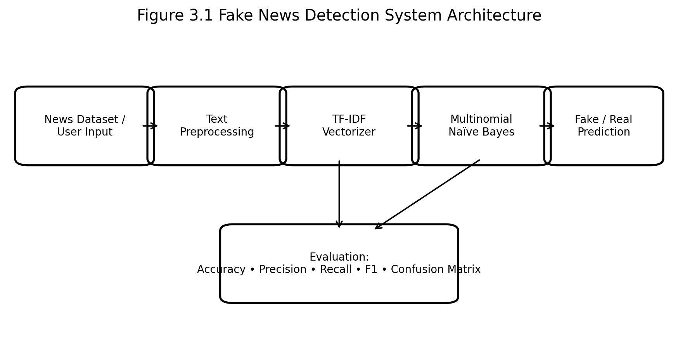
Figure 3.1 – Fake News Detection System Architecture
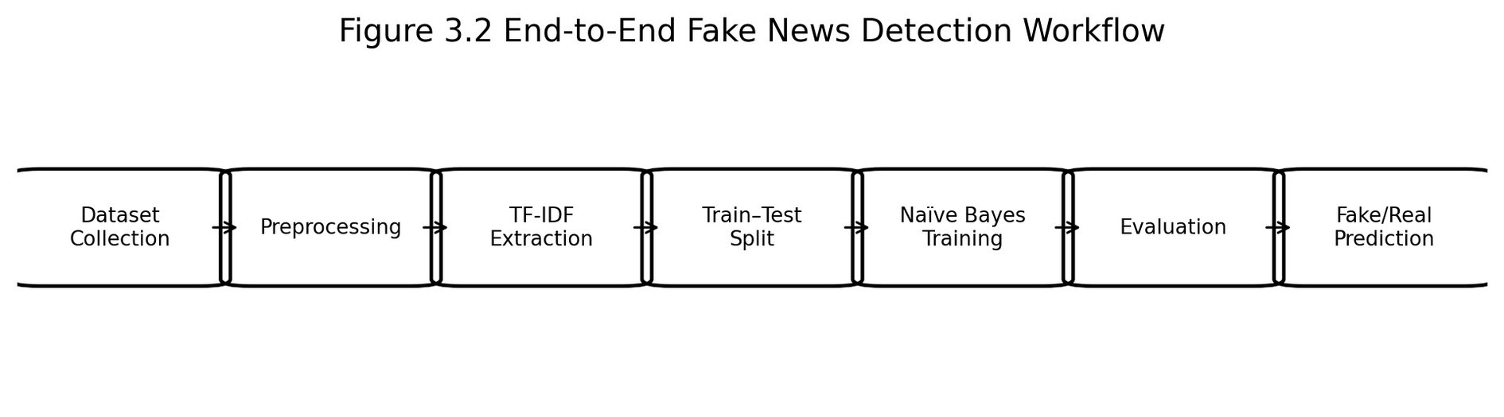
Figure 3.2 – End-to-End Fake News Detection Workflow
Systems approach: the dataset supplies the raw information; preprocessing converts it into usable text; TF-IDF provides numerical features; the classifier learns relationships between features and labels; and the evaluation stage verifies performance on unseen data. The prediction stage uses the same representation pipeline to classify new news content.

3.6.1 Alternative Machine Learning Solutions

Approach | Advantages | Limitations | Decision
Multinomial Naïve Bayes | Efficient and well suited to text classification | Limited contextual understanding | Selected
Logistic Regression | Strong classical text-classification baseline | Requires tuning | Future comparison
Support Vector Machine | Effective with high-dimensional text features | More tuning/compute may be required | Future comparison
Decision Tree / Random Forest | Flexible classification approach | Less direct for sparse text representation | Future comparison
Deep Learning / Transformers | Strong contextual understanding | Higher data and computational requirements | Future work

3.6.2 Design Trade-offs

Decision | Alternative | Benefit | Trade-off
Text representation | Raw text | TF-IDF gives numerical features for ML | Does not capture full semantics
Classifier | Complex deep model | Naïve Bayes is lightweight and easy to implement | May miss complex language context
Evaluation | Accuracy only | Multiple metrics provide broader assessment | Requires additional analysis
Interface | Full web application | Current approach is simpler for prototype development | Less convenient for deployment

3.6.3 Sustainability, Ethics, Safety and Security

Area | Consideration | Engineering Response
Sustainability | Automated screening can reduce repetitive manual review | Use efficient text-processing methods
Ethics | Predictions can affect trust in information | Present output as a prediction, not absolute truth
Safety | False classification may mislead users | Human verification and fact-checking remain necessary
Security | Input data may be untrusted or sensitive | Validate inputs and control data access

3.6.4 Risk Register

Risk | Likelihood | Impact | Mitigation
Poor-quality/incomplete dataset | Medium | High | Clean and validate data
Dataset bias | Medium | High | Use diverse data and evaluate class balance
High-dimensional features | Medium | Medium | Tune TF-IDF vocabulary/features
Similar fake and real writing styles | High | High | Compare algorithms and advanced NLP

Results and Recommendations

4.1 Development Approach & Resources
The development approach follows a staged machine-learning workflow. The labelled dataset is loaded and inspected, textual content is prepared, TF-IDF features are generated, and the data is divided into training and testing subsets. The Multinomial Naïve Bayes model is trained using the training data and evaluated on unseen test data. The workflow then supports prediction for new textual content.
Resource | Purpose
Python | Primary programming language
Pandas | Dataset loading and data management
Scikit-learn | TF-IDF, train-test split, classifier and evaluation
Matplotlib | Graphs and visualizations
Jupyter Notebook / Visual Studio Code | Development, execution and debugging
Fake news dataset | Labelled text data for model training/testing

4.2 Software Implementation & Modern Tools Used
Tool / Software | Purpose | Stage Used
Python | Program implementation | All stages
Pandas | CSV/data handling | Data collection and preprocessing
TF-IDF Vectorizer | Text-to-feature conversion | Feature extraction
Multinomial Naïve Bayes | Classification | Model training/prediction
Scikit-learn metrics | Evaluation | Testing and analysis
Matplotlib | Result visualization | Results
Jupyter Notebook / Visual Studio  Code | Development and debugging | Implementation
Implementation flow: dataset loading → data validation → text preprocessing → TF-IDF vectorization → train/test split → Multinomial Naïve Bayes training → prediction → evaluation → visualization.

4.3 Test Plan & Verification
Requirement | Test Method | Acceptance  Criterion | Required  Value | Achieved  Value | Status
Dataset loading | Read dataset and inspect columns | Required  text/label fields available | Text + Label | To be taken from actual run | Record after execution
Preprocessing | Inspect cleaned text and missing values | Usable text for vectorization | No blocking missing/invalid input | To be taken from actual run | Record after execution
TF-IDF | Fit vectorizer on training text | Feature matrix generated | Non-empty feature matrix | To be taken from actual run | Record after execution
Model training | Fit Multinomial  Naïve Bayes | Training completes without error | Model fitted | To be taken from actual run | Record after execution
Prediction | Predict unseen test data | Fake/Real labels produced | Predictions for all test records | To be taken from actual run | Record after execution
Evaluation | Calculate standard metrics | Metrics and confusion matrix generated | Accuracy, precision, recall, F1 | To be taken from actual run | Record after execution

4.4 Results
The source report specifies the evaluation procedure but explicitly states that exact accuracy and other performance values should be taken from the actual output generated with the selected dataset. Therefore, this edited report does not invent numerical performance values. The following figures are retained as workflow and visualization evidence from the source report.

4.4.1 Evaluation Metrics
Metric | Meaning | Interpretation
Accuracy | Overall proportion of correct predictions | Higher value indicates more correct predictions overall.
Precision | Proportion of predicted positive/class examples that are | Indicates reliability of positive/class predictions.
 | correct
Recall | Ability to identify relevant examples | Indicates how many relevant examples are detected.
F1-score | Harmonic combination of precision and recall | Useful for balanced assessment.
Confusion Matrix | Counts correct and incorrect predictions by class | Shows Fake→Fake, Real→Real, Fake→Real and Real→Fake outcomes.

Figure 4.1 AI Development Workflow Stages – Bar Graph

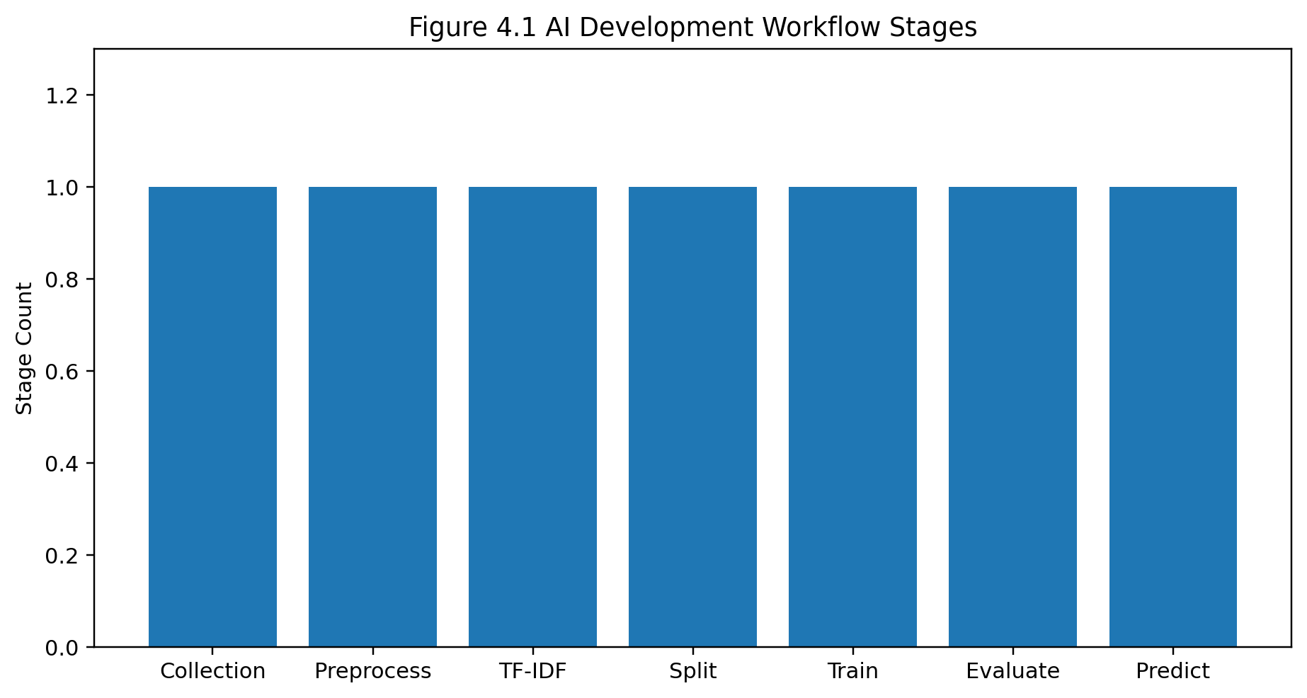

Figure 4.2 Conceptual Pipeline Progression – Line Graph

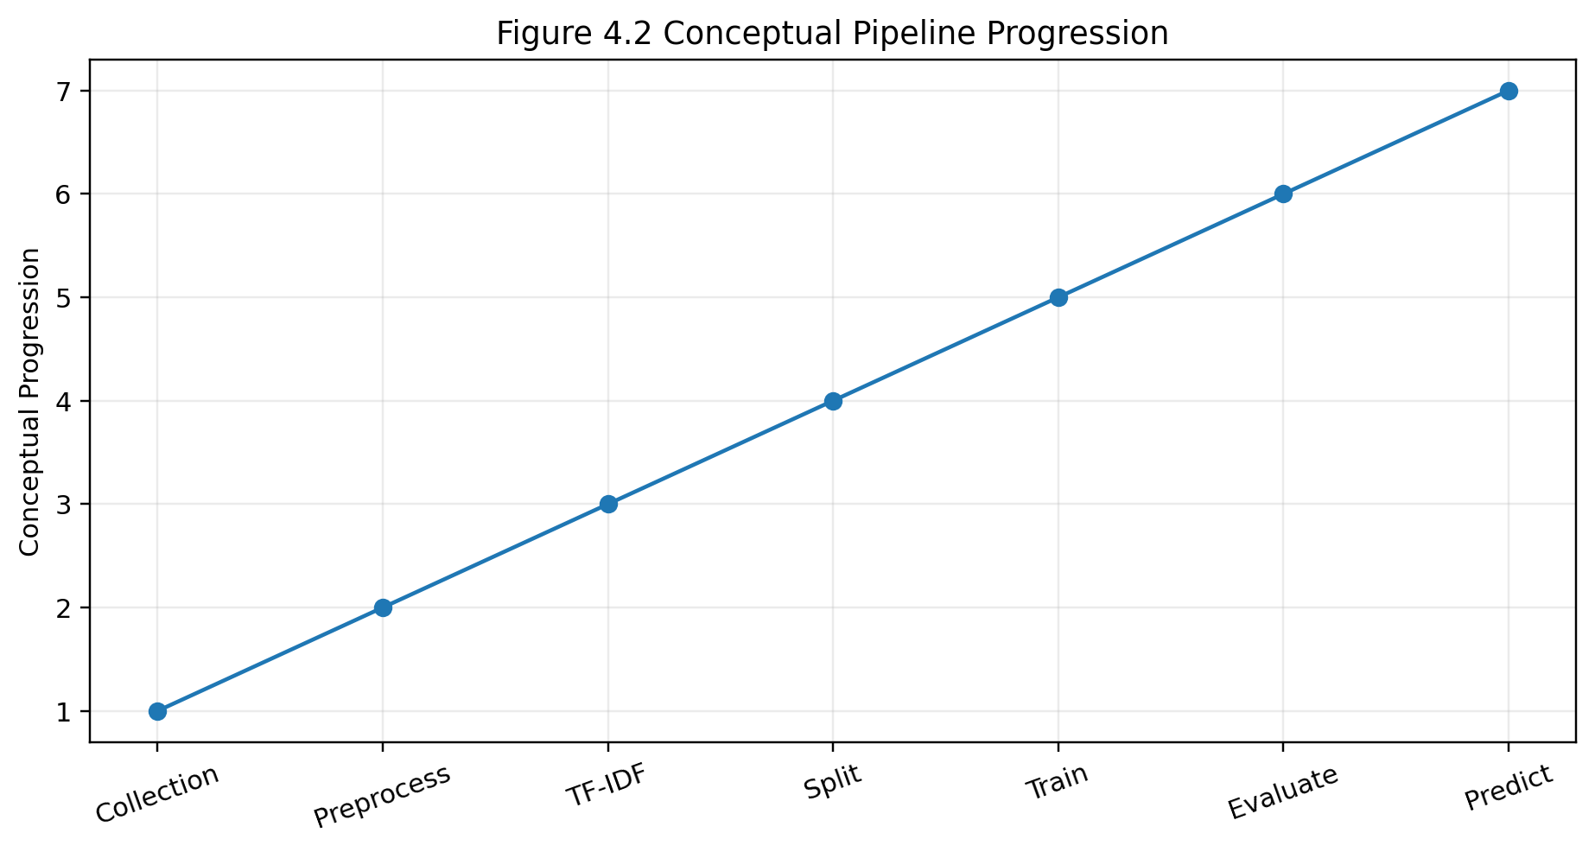

Figure 4. 3 Technology Categories Used – Pie Chart

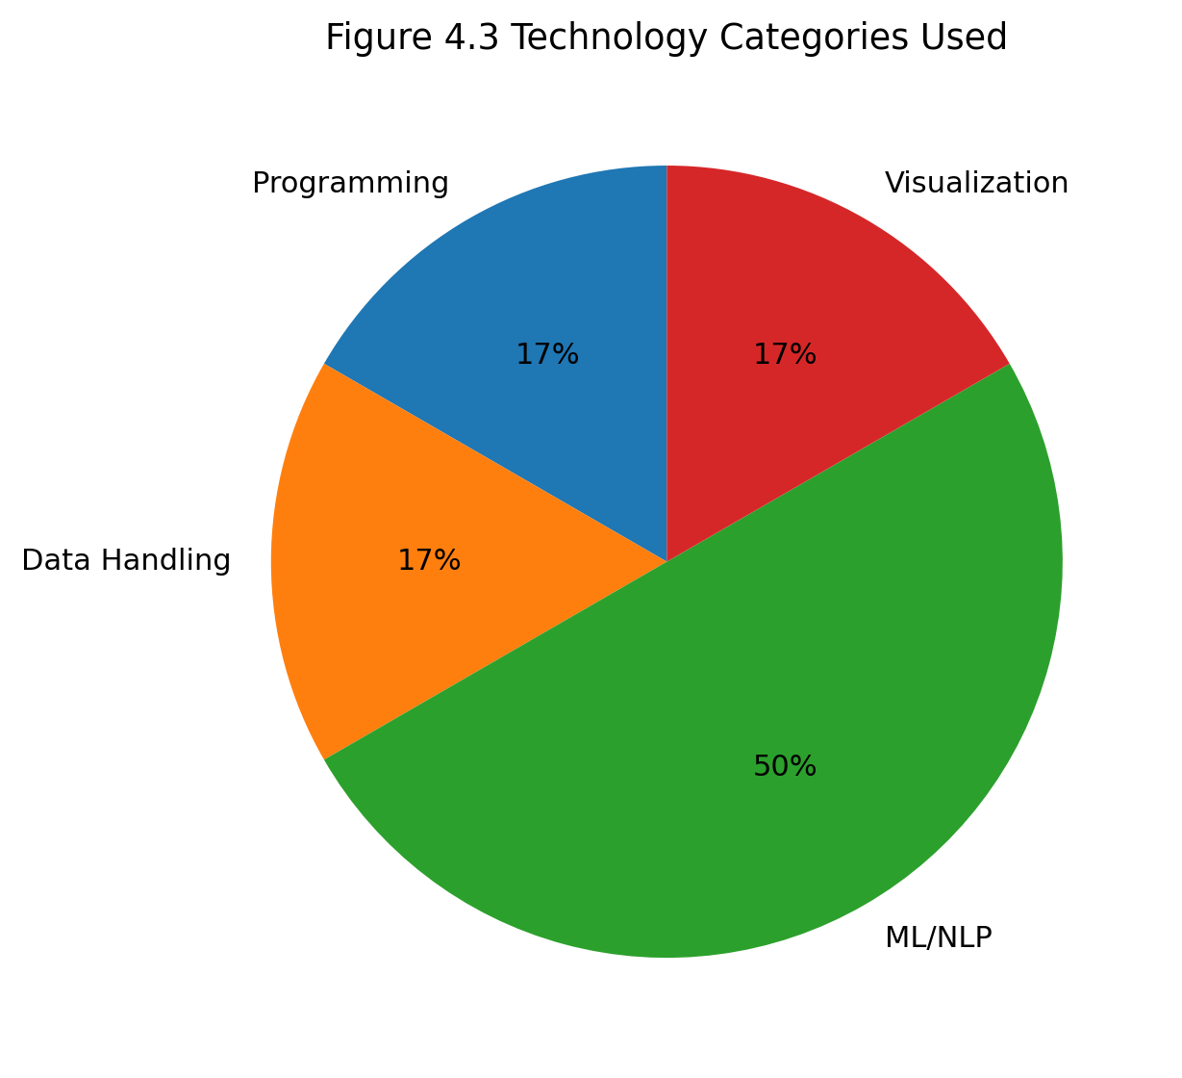

Figure 4.4 Illustrative Growth of Text Feature Space – Scatter Graph

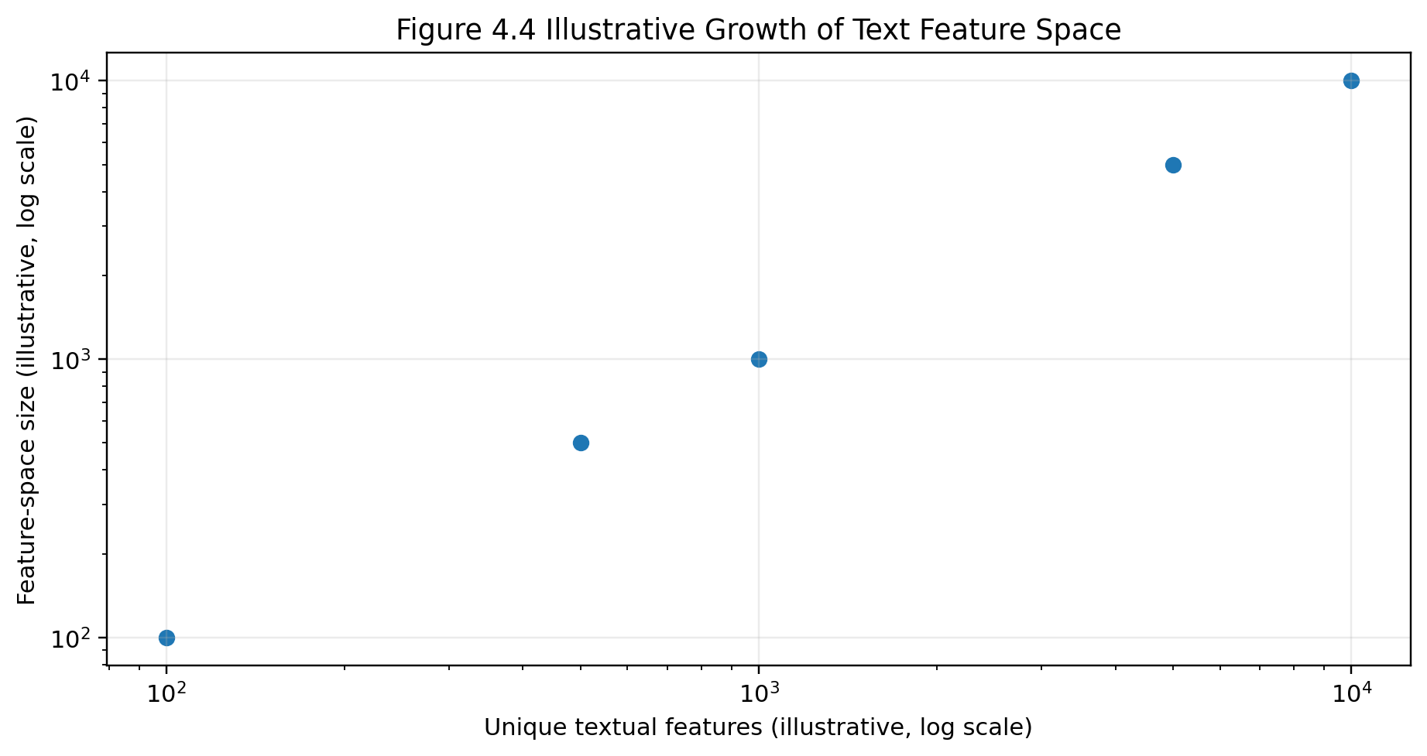

4.5 Data Analysis & Engineering Judgment
The evaluation framework is designed to assess more than overall accuracy. Precision and recall help identify whether errors are concentrated in a particular class, while F1-score provides a combined view of precision and recall. The confusion matrix is particularly useful for identifying false positives and false negatives. Because the final numerical output is not included in the source report, engineering judgment should be completed after the implementation is executed and the measured values are entered into the results table.
Metric | Measured Result | Engineering Interpretation
Accuracy | Not supplied in source report | Populate from actual model output.
Precision | Not supplied in source report | Populate from actual model output.
Recall | Not supplied in source report | Populate from actual model output.
F1-score | Not supplied in source report | Populate from actual model output.
Confusion matrix | Not supplied in source report | Insert actual matrix from model execution.

4.6 Comparison with Existing Solutions & Achievement of Objectives
Objective | Evidence | Achievement
Automated Fake/Real classification | Implemented ML classification workflow | Fully supported by documented design; verify through execution
Dataset processing | Pandas-based loading and preprocessing workflow | Fully supported
TF-IDF feature extraction | TF-IDF Vectorizer stage | Fully supported
Multinomial Naïve Bayes training | Classifier stage | Fully supported
Performance evaluation | Accuracy, precision, recall, F1 and confusion matrix specified | Partially evidenced until actual values are inserted
New-text prediction | Prediction stage documented | Supported by design; verify through execution

4.7 Strengths & Limitations

Strengths
- Simple and efficient text-classification workflow.
- Uses a standard TF-IDF representation with a lightweight classifier.
- Provides multiple evaluation measures rather than accuracy alone.
- Easy to reproduce and extend with alternative algorithms. • Suitable as an educational and initial screening prototype.

Limitations
- Limited contextual and semantic understanding compared with transformer models.
- Performance depends strongly on dataset quality, diversity and labels.
- The system does not independently verify facts against external evidence.
- Changing misinformation patterns can reduce generalization.
- Final numerical performance values are not documented in the source report and must be obtained from actual execution.

4.8 Project Planning, Roles & Budget
Milestone | Planned Activity | Primary Responsibility
1 | Problem definition and literature review | Both students
2 | Dataset collection and inspection | ADDAGADA MEGHANADH
3 | Preprocessing and TF-IDF | ADDAGADA MEGHANADH
4 | System architecture and workflow | A. THARUN KUMAR REDDY
5 | Model training and testing | Both students
6 | Graphs, analysis and documentation | A. THARUN KUMAR REDDY
7 | Final report integration and review | Both students
Student | Assigned Responsibility | Actual Contribution
ADDAGADA MEGHANADH | Data preparation, TF-IDF, model implementation, testing | 50%
A. THARUN KUMAR REDDY | Architecture, workflow, visualization, analysis, documentation | 50%
Budget Item | Estimated Cost ( )₹ | Actual Cost ( )₹
Software / Python libraries | 0 | 0
Development environment | 0 | 0
Dataset / public resources | 0 | 0
Printing / documentation | To be entered | To be entered
Total | To be entered | To be entered

Reflection on Learning and Personal Development

5.1 Key Learning Outcomes
The development of the Fake News Detection System provided valuable learning experiences in the areas of Natural Language Processing (NLP), Machine Learning, data analysis, and Python programming. The project helped us understand how artificial intelligence techniques can be applied to solve real-world problems related to misinformation and digital content.
One of the major learning outcomes was understanding the complete machine learning workflow. The project involved collecting a labelled dataset, loading the data, preprocessing textual information, extracting meaningful features, training a machine learning model, and evaluating its performance. This provided practical knowledge of how machine learning systems are developed from the initial data stage to the final prediction stage.
We also gained knowledge about text preprocessing. Raw textual data may contain missing values, unwanted characters, punctuation, URLs, and inconsistent information. Preparing the dataset properly is important because the quality of input data directly affects machine learning performance.
Another important learning outcome was understanding the TF-IDF (Term Frequency–Inverse Document Frequency) technique. TF-IDF converts textual information into numerical feature vectors that can be processed by machine learning algorithms. This helped us understand how computers can analyse and learn from human language.
The project also provided practical experience with the Multinomial Naïve Bayes algorithm. We learned how probabilistic classification can be used to predict whether a news article belongs to the Fake or Real category.
In addition, we improved our understanding of performance evaluation using accuracy, precision, recall, F1-score, and confusion matrices. These metrics helped us understand that machine learning models should be evaluated using multiple measures rather than accuracy alone.
Overall, the project strengthened our knowledge of Python, data preprocessing, NLP, machine learning algorithms, model evaluation, and real-world AI applications.

5.2 Challenges Encountered and Overcome
Several challenges were encountered during the development of the Fake News Detection System. These challenges provided opportunities to improve our technical knowledge and problem-solving skills.
One of the main challenges was handling the dataset. Datasets may contain missing values, incomplete records, duplicated information, or inconsistent labels. These problems were addressed by checking the dataset carefully and applying appropriate preprocessing methods before training the model.
Another challenge was text preprocessing. Raw news articles contain large amounts of unstructured text, and not all information is useful for classification. Understanding how to clean and prepare the textual data required testing and experimentation.
Feature extraction was also a challenge because machine learning algorithms cannot directly understand raw text. The problem was addressed by using the TF-IDF Vectorizer, which converts textual documents into numerical features.
Another important challenge was selecting an appropriate machine learning algorithm. The Multinomial Naïve Bayes algorithm was selected because it is suitable for text classification and can efficiently process high-dimensional textual features.
Model evaluation also required careful analysis. A model may provide good overall accuracy but still make incorrect predictions for certain categories. Therefore, additional metrics such as precision, recall, F1-score, and the confusion matrix were used to understand the model's performance more clearly.
These challenges improved our debugging abilities, analytical thinking, patience, and problem-solving skills. By testing each stage of the system systematically, we were able to overcome implementation difficulties and improve the overall development process.

Individual Reflection – ADDAGADA MEGHANADH
The most difficult engineering problem was preparing textual data so that it could be used reliably by a machine-learning model. I addressed this by following a structured preprocessing and TF-IDF workflow and checking the data before model training. A key engineering decision was selecting Multinomial Naïve Bayes because it is lightweight and appropriate for text classification. I independently strengthened my understanding of data preparation, feature extraction and evaluation. If the project were repeated, I would add stronger data validation and compare several classifiers using the same dataset.

Individual Reflection – A. THARUN KUMAR REDDY
A major challenge was organizing the complete workflow into a clear engineering system and presenting its results using appropriate visualizations. I worked on the architecture, workflow representation, graphs, analysis and documentation so that each stage could be traced from input to output. A key engineering decision was to use multiple evaluation metrics rather than relying on accuracy alone. I gained additional experience in model interpretation, technical reporting and team coordination

Conclusion

The Fake News Detection System successfully demonstrates the application of Natural Language Processing (NLP) and Machine Learning techniques to address the growing problem of misinformation in digital media. With the rapid growth of online news platforms and social media, large amounts of information are shared every day. Among this information, false and misleading content can spread quickly and create confusion among users. Therefore, the development of automated systems that can analyse news content and identify potentially fake information has become increasingly important.
The proposed system provides a structured approach for classifying textual news content into Fake and Real categories. The development process includes dataset collection, data preprocessing, text cleaning, feature extraction, machine learning model training, testing, and prediction. The TF-IDF (Term Frequency–Inverse Document Frequency) technique is used to transform textual news articles into numerical feature vectors that can be processed by machine learning algorithms. The Multinomial Naïve Bayes classifier is then used to learn patterns from labelled news data and predict the category of previously unseen news articles.
The project demonstrates the importance of proper data preparation and feature extraction in developing an effective text classification system. The performance of the model can be evaluated using standard metrics such as accuracy, precision, recall, F1-score, and a confusion matrix. These evaluation methods help analyse the ability of the model to correctly classify news articles and identify possible prediction errors.
The Fake News Detection System provides a useful automated method for the initial screening of potentially misleading information. However, the prediction generated by the machine learning model should not be considered absolute proof that a particular article is true or false. The system depends on the quality, diversity, and accuracy of the training dataset. Therefore, human verification and professional fact-checking remain important for confirming factual information.
The project also provides significant educational value by demonstrating the complete machine learning workflow using Python, Pandas, Scikit-learn, TF-IDF, and Naïve Bayes classification. It improves understanding of data preprocessing, NLP, machine learning algorithms, performance evaluation, debugging, and system development.
In conclusion, the Fake News Detection System provides a practical, low-cost, and scalable approach to automated news classification. It establishes a strong foundation for future development in misinformation detection and digital content analysis.

References

[1] K. Shu, A. Sliva, S. Wang, J. Tang, and H. Liu, “Fake News Detection on Social Media: A Data Mining Perspective,” SIGKDD Explorations, vol. 19, no. 1, pp. 22–36, 2017.

[2] W. Y. Wang, “Liar, Liar Pants on Fire: A New Benchmark Dataset for Fake News Detection,” in Proceedings of the 55th Annual Meeting of the Association for Computational Linguistics, 2017, pp. 422–426.

[3] N. J. Conroy, V. L. Rubin, and Y. Chen, “Automatic Deception Detection: Methods for Finding Fake News,” Proceedings of the Association for Information Science and Technology, vol. 52, no. 1, pp. 1–4, 2015.

[4] V. Pérez-Rosas, B. Kleinberg, A. Lefevre, and R. Mihalcea, “Automatic Detection of Fake News,” in Proceedings of COLING, 2018, pp. 3391–3401.

[5] K. Shu, D. Mahudeswaran, S. Wang, D. Lee, and H. Liu, “FakeNewsNet: A Data Repository with News Content, Social Context, and Dynamic Information for Studying Fake News on Social Media,” Big Data, vol. 8, no. 3, pp. 171–188, 2020.

[6] H. Ahmed, I. Traore, and S. Saad, “Detection of Online Fake News Using N-Gram Analysis and Machine Learning Techniques,” in International Conference on Intelligent, Secure, and Dependable Systems in Distributed and Cloud Environments, 2017, pp. 127–138.

[7] M. Granik and V. Mesyura, “Fake News Detection Using Naive Bayes Classifier,” in 2017 IEEE First Ukraine Conference on Electrical and Computer Engineering, 2017, pp. 900–903.

[8] S. B. Parikh and P. K. Atrey, “Media-Rich Fake News Detection: A Survey,” in 2018 IEEE Conference on Multimedia Information Processing and Retrieval, 2018, pp. 436–441.

[9] S. Kaliyar, A. Goswami, and P. Narang, “FakeBERT: Fake News Detection in Social Media with a BERT-Based Deep Learning Approach,” Multimedia Tools and Applications, vol. 80, pp. 11765–11788, 2021.

[10] A. Bondielli and F. Marcelloni, “A Survey on Fake News and Rumour Detection Techniques,” Information Sciences, vol. 497, pp. 38–55, 2019.

[11] J. Reis, A. Correia, F. Murai, A. Veloso, and F. Benevenuto, “Supervised Learning for Fake News Detection,” IEEE Intelligent Systems, vol. 34, no. 2, pp. 76–81, 2019.

[12] C. C. Aggarwal and C. Zhai, Mining Text Data. New York, NY, USA: Springer, 2012.

[13] C. D. Manning, P. Raghavan, and H. Schütze, Introduction to Information Retrieval. Cambridge, U.K.: Cambridge University Press, 2008.

[14] I. H. Witten, E. Frank, M. A. Hall, and C. J. Pal, Data Mining: Practical Machine Learning Tools and Techniques, 4th ed. Burlington, MA, USA: Morgan Kaufmann, 2016.

[15] F. Pedregosa et al., “Scikit-Learn: Machine Learning in Python,” Journal of Machine Learning Research, vol. 12, pp. 2825–2830, 2011.

APPENDICES

Appendix A – Detailed Calculations / Evaluation Formulas
Accuracy = Number of Correct Predictions / Total Number of Predictions
Precision measures how many items predicted as a class are actually correct.
Recall measures the ability of the classifier to identify relevant examples of a class.
F1-score combines precision and recall into a single balanced measure.

Appendix B – Engineering Drawings / Schematics

Appendix Figure B.1 – System architecture

Appendix Figure B.2 – Workflow

Appendix C – Source Code / Code Repository Information
The implementation is based on Python, Pandas, Scikit-learn, TF-IDF Vectorizer and
Multinomial Naïve Bayes. Only essential code excerpts should be placed in the final report; the complete source code may be maintained in the approved repository or submission package.

Appendix D – Dataset Schema
Column Name | Description
Text | Contains the news article or news content
Label | Indicates whether the news is Fake or Real

Appendix E – Experimental / Raw Data
Text | Label
Sample news article content | FAKE
Verified news article content | REAL
These entries are illustrative examples retained from the source report and should not be treated as the full experimental dataset.

Appendix F – Ethics / Institutional Approval
Not applicable based on the source report. If the final implementation uses human-subject data or restricted data, the appropriate institutional approval documentation should be added.

Appendix G – Project Meeting / Progress Records
To be completed with actual meeting dates, milestones, decisions, and supervisor feedback if required by the department.
Appendix H – User / Industry Feedback
To be added if feedback was collected.

Appendix J – Individual Contribution Evidence
Student | Evidence
ADDAGADA MEGHANADH (192572132) | Dataset preparation, preprocessing, TF-IDF/model implementation and testing evidence.
A. THARUN KUMAR REDDY (192572068) | Architecture, workflow, visualization, analysis and documentation evidence.

CAPSTONE PROJECT OUTCOME MAPPING SHEET
Outcome | SO / Area | Location in This Report
Complex engineering problem formulation | SO1 | Ch. 1, Ch. 2
Engineering design under constraints | SO2 | Ch. 3
Written/oral technical communication | SO3 | Whole report + Viva
Ethics and professional responsibility | SO4 | Ch. 3.7 and Ch. 5
Teamwork and leadership | SO5 | Ch. 4.8
Experimentation, analysis, engineering judgment | SO6 | Ch. 4.3–4.6
Independent acquisition of new knowledge | SO7 | Ch. 5.3
Standards / engineering practices | SO2 | Ch. 3.2
Sustainability and  societal/environmental impact | SO2/SO4 | Ch. 3.7
Risk assessment and mitigation | SO2/SO4 | Ch. 3.7
Security considerations | Relevant SO | Ch. 3.7
Integrated/system-level engineering | SO1/SO2 | Ch. 3.5
Project planning and management | SO5 | Ch. 4.8
Individual contribution | SO1–SO7 | Contribution Statement + Ch. 4.8

